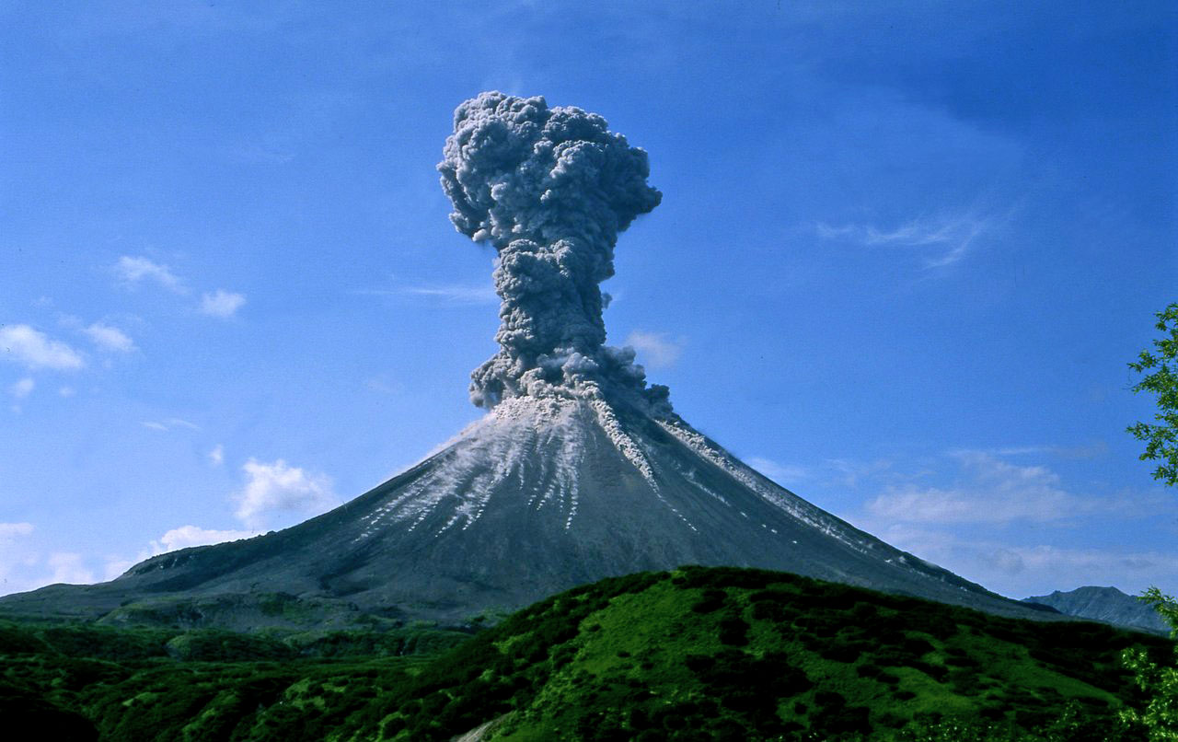A

**Literacy**

**Firework Makers Daughter is our text this term and we will be covering these aspects of the curriculum:**

**Narrative writing**

**Diary entries**

**Non chronological reports**

**News reports**

Year 3

Autumn 2

Tremors

**Maths**

**Number**

**place value**

**Multiplication**

**division**

**Fractions**

**Geography**

**Volcanoes and earthquakes- locally and around the world.**

**DT**

**Sculptures – in particular volcanoes linked to our science and topic learning**.

**PE**

**Games**

**Our PE days are**

**Tuesday, Wednesday for 3S & Wednesday and Friday for 3W**

**Science**

**Rocks and Soils**

**This term we will be exploring different types of rocks and their properties, carrying out simple and practical activities and investigating the effect volcanoes have. We will also be holding another parent celebration afternoon. We hope to see you there!**

**RE**

**Reconciliation**

**Multi Faith Week**

**Advent/Christmas**

**ICT**

**Presenting Information**