Year 3

Spring 1

Tribal Tales

**Literacy**

**Stig of the Dump is our text this term and we will be covering these aspects of the curriculum:**

**Narrative**

**Reports**

**Letters**

**Poetry**

**Maths**

**Number**

**Measurement**

**Time**

**Money**

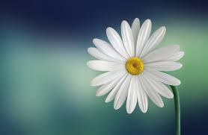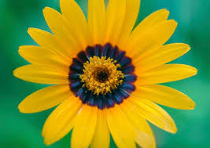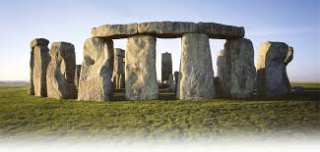

**Science**

**Plants (How does your Garden Grow?**

**This term we will be exploring the life-cycle of plants, exploring the best conditions for a plant to grow and investigating the importance of each part of a plant.**

**ICT**

**Bringing Images to Life**

**PE**

**Gymnastics/Dance**

**Our PE days are**

**Tuesday & Thursday**

**History**

**Prehistoric Britain – From stone age to the Iron Age.**

**Art/DT**

**Drawing/ painting plants in colour – life cycle plan based on Henri Rousseau**

**RE**

**Local Church**

**Eucharist**