Year 3

Spring 2

Urban Pioneers

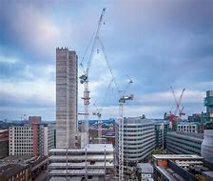

**PE**

**Gymnastics/Dance**

**Our PE days are**

**Tuesday and Wednesday’s (3S) & Thursday and Friday (3D)**

**Maths**

**Number**

**Measurement**

**Geometry**

**Science – Forces and Magnets**

**This half term we will be investigating and exploring how forces such as push and pull work, and how magnets work.**

**We will also be looking closely at everyday uses of forces and magnets.**

**Literacy**

**We will be covering these aspects of the curriculum:**

**Persuasive and balanced arguments**

**Leaflets**

**Brochure**

**Letter Writing**

**RE**

**Local Church**

**Eucharist**

**Art/DT**

**Drawing/ painting based on Banksy and graffiti artwork.**

**ICT**

**Bringing Images to Life**