Year 3

Summer 2

Gods and Mortals

**Literacy**

**This half term we will be linking our literacy learning to our topic of Gods and Mortals. We will cover areas such as;**

**Myths**

**Leaflets and brochures**

**Report Writing**

**Maths**

**Gaps Coverage –**

**Shape/Measure**

**Money**

**Time**

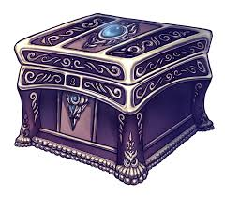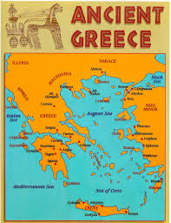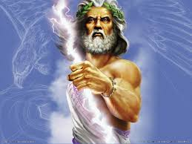

**Geography**

Maps/ Ancient and modern day Greece

**Art/DT**

Architects/ drawing/ painting-repeated patterns/ mosaic patterns

**Science**

**Light and Dark.**

**This term we will be exploring light and dark and understand how shadows are formed.**

**ICT**

**Sharing Information/ Communicating online.**

**PE**

**Athletics**

**History**

**We will be exploring Ancient Greece’s history and its influence in our society today.**

**RE**

**Pentecost/ Universal Church**