**Wk 2**

**Literacy:** Autumn & bonfire night (introduce Owl babies)

**Maths:** Counts out objects from a larger group, making estimates

**KUW:** Light and dark

**RE**: Friends

**Hwk:** Shape home learning – choose own challenge

**Wk 1**:

**Literacy:** Diwali

**Maths:** 2D shapes- names and properties

**Art:** Autumn leaves collage

**RE:** Friends

**Hwk:** Signs of Autumn

**Wk 3**

**Literacy**: Owl babies (Changes to environment)

**Maths**: Sequencing events and days of the week

**KUW:** Electricity

**RE:** Multi-faith week – World Religions

**Hwk:** Snakes and ladders HFWs



**Wk 4**

**Literacy**: Owl babies (hibernation)

**Maths:** length and height (ordering and non-standard measure)

**KUW:** Materials

**RE**: Advent

**Hwk:** Phase 2 board game

**Wk 8**

**Literacy**: Christmas stories

**Maths:** 1 less than

**KUW:** Christmas activities

**RE:** Caritas week

**Hwk:** Missing numbers

**Seasons/ Christmas**

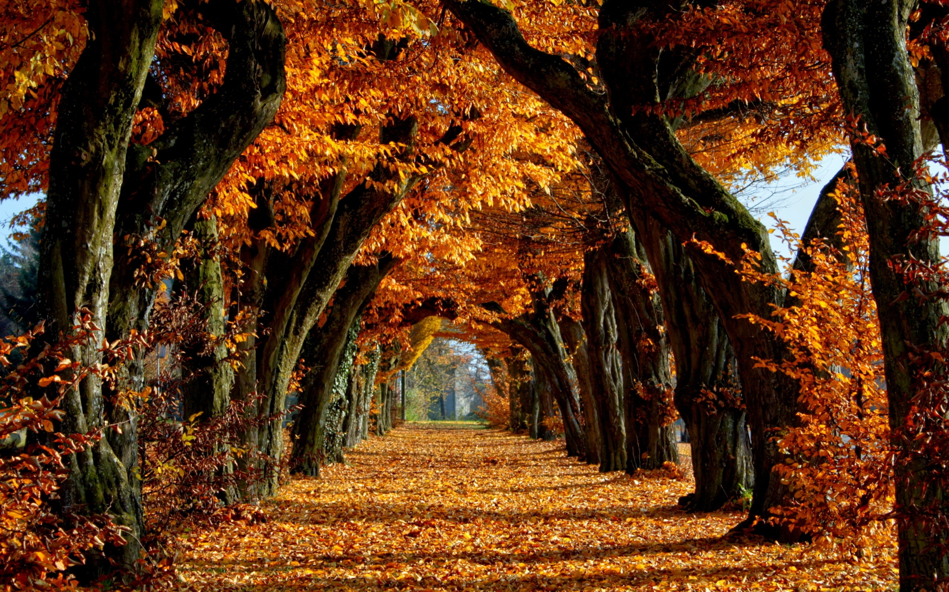

**Wk 6**

**Literacy**: Stickman

**Maths:** Number sentences (using pictures & numbers)

**KUW:** Materials

**RE**: Advent

**Hwk:** Number formation

**Wk 7**

**Literacy:** Nativity stories

**Maths:** positional language & 1 less than

**KUW:** Nativity

**RE**: Advent

**Hwk:** Naughty elf letter

**Wk 5**:

**Literacy:** Stickman (Winter)

**Maths:** adding 2 groups of objects, adding by counting on

**KUW:** Materials

**RE**: Advent

**Hwk:** Dressing for winter