**Wk 2**

**Literacy:** Whatever Next: Baby bear learns about other planets – fact file

**Maths:** Bonds to 10

**RE:** Good News

**KUW/ EAD:** Peter Thorpe Space Art

**HWK:** Doubling problems

**Wk 1**:

**Literacy:** Whatever Next: Postcard, invitation

**Maths:** Odd and even numbers

**RE:** Good News

**KUW/ EAD:** Peter Thorpe Space Art

**HWK:** Look at the night sky. What can you see?

**Wk 3**

**Literacy:** Introduce 5 sentence stories (compose & write own space story)

**Maths:** Adding on a number line

**RE:** Our World

**KUW/ EAD:** Materials in space

**HWK:** Can you design your own rocket?



**Space**

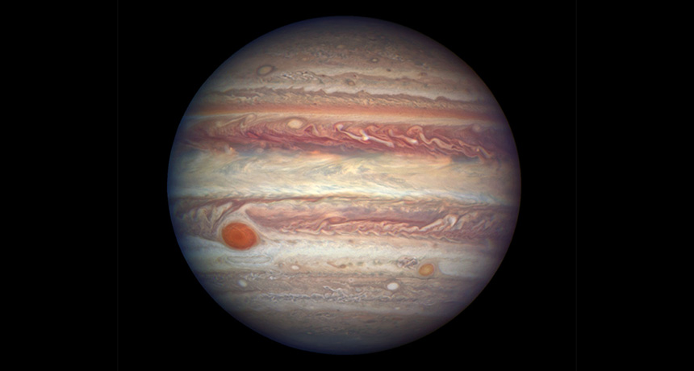

**Wk 4:**

**Literacy:** Toys in Space – lost poster, write predictions for middle and end of story

**Maths:** Ordinal numbers & 3D shape

**RE:** Our World

**KUW/ EAD:** Making craters

**HWK:** Sharing problems

**Wk 6**

**Literacy:** How to catch a star

**Maths:** Money

**RE:** Our World

**KUW/ EAD:** Transition activities

**Wk 5**:

**Literacy:** Toys in space – write a report on naughty alien for stealing toys, look at astronauts

**Maths:** Subtraction on a number line

**RE:** Our World

**KUW/ EAD:** Transition activities

**HWK:** Pretend to be an astronaut. Write in your log book.