**Wk 2**

**Literacy:** Non-fiction caterpillars – life cycle, fact-file

**Maths:** Number bonds to 5 (HA: inverse)

**RE**: Easter

**HWK:** Minibeast hunt

**Wk 3**

**Literacy**: Norman the Slug with the Silly Shell –diary entry, letter

**Maths**: Number bonds to 10

**RE:** Easter

**HWK:** Caterpillar favourite foods

**Wk 1** :

**Literacy:** The Very Hungry Caterpillar – shopping list, food diary

**Maths:** **Time –** LA: DOW, MA: minutes, seconds & hours HA: o’clock & half-past

**RE:**Easter

**HWK:** Hungry Caterpillar maths problems



**Minibeasts**

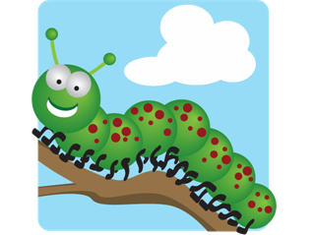

**Wk 6**:

**Literacy:** aaarrgghh spider – letter from spider

**Maths:** 1 more & 1 less

**RE**: Pentecost

**HWK:** Design own super minibeast

**Wk 4**

**Literacy**: Non-fiction: Slugs and snails (look at similarities and differences) – fact file

**Maths:** Number bonds to 10 (HA: inverse)

**RE**: Easter

**HWK:** Minibeast maths

**Wk 5**:

**Literacy:** Superworm – rhyming, potion making/ spell writing

**Maths:** Subtraction recap & on a number line

**RE**: Pentecost

**HWK:** What do tadpoles turn into?