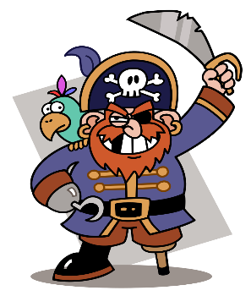

How can you help?

* Research famous pirates together e.g. Blackbeard, Williams Kidd, Anne Bonny and Grace O’Malley
* Make some pirate treasure maps together.
* Talk about different places the pirates visited and how they lived.
* Practise counting from 0-10 forwards and backwards.
* Practise recognising numerals 0-5
* Look at different 2D and 3D shapes in the world around you and talk about what you notice about them.
* Practise reading some of the set 1 high frequency words that will be sent home in reading records.
* Play free educational games online (google phonicsplay and topmarks)
* Practise using scissors at home.
* Look on Pinterest for fine motor activities. These will help your child to hold and control their pencil e.g. using playdough, using tweezers
* Read with your child every night.

**Spring 1: Walk the Plank**

We will be learning to:

**Communication and language (C&L)**

* Use more complex sentences when speaking (say words such as ‘and’ ‘because’ to link our thoughts).
* Compose our own questions using: who, what, why, when, where
* Answer questions and ask questions about pirates
* Retell a story

**Mathematics (M)**

* Count to 10
* Recognise numerals 0-5
* Count objects using 1:1 correspondence
* Match numeral to quantity to 5
* Finding one more for number

up to 5

* Recognise and talk about 2D shape
* Recognise and talk about 3D shape

**Personal, social and emotional development (PSED)**

* Feel confident and proud of ourselves and others
* Say things that we are good at
* Try to solve conflicts ourselves before coming to an adult for help
* Speak to others about what we have learnt about pirates



Reminders:

* Please check bags for letters and homework.
* Homework will be sent home on a Wednesday. Please send it back by the following Wednesday.
* When you drop off your child please feel free to speak to your child’s teacher about all the fantastic work they have been doing at home.
* Don’t forget you can add to your child’s online learning journey.
* You might even want to bring some work from home in to nursery to show the class.
* Please bring in any empty boxes/containers etc. for children to use in our creative area.
* Don’t forget to bring in your child’s reading book. Books will be changed on a Monday and Thursday.

**Literacy (L)**

* Listen to Pirate stories with increasing attention and recall
* Retell some familiar pirate stories
* Begin to form some recognisable letters in our names
* Listen to some initial sounds in some familiar words
* Begin to read some high frequency words

**Expressive Art and Design (EAD)**

* Make boats that float
* Sing pirate songs
* Mix colours
* Find ways to make our creations even better
* Use stories/ information that we have learnt, to build up a role play

**Understanding the World (KUW)**

* Make our own maps
* Talk about floating and sinking
* Talk about who pirates were and what they did

**Physical Development (PD)**

* Hold our pencil using a three fingered grip
* Get dressed by ourselves
* Draw lines and circles with good control
* Form some recognisable letters in our name