Spring 1:

Dear Parents/ Carers,

during this half term the following topics will be studied in your child’s class.
I hope that this information, together with some ideas for working with your child at home, will both keep you up to date as regard what your child is doing in school and also help you to support your child’s learning.

 | Work covered in school | Ways you can help your child at home
Religion   | We will be learning about our church community and special people who help us. We will be looking at the traditions and celebrations that we share. | - Discuss celebrations that you have had in the past e.g. baptisms, communions, weddings. How did you celebrate? Who took part?  - Talk about your community and who is a part of it. How do we look after our community?  - Take part in a community experience
Literacy  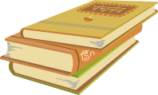 | Children will read ‘Meerkat Mail’ and write their own post-cards as if they were Sunny the meerkat writing back to his mob in the Kalahari desert.  Children will look at information texts about animals and then write their own about meerkats.  Finally we will research animal charities such as Green Peace and WWF, then we will write a letter to Mr Jones asking if we can adopt an animal. | - Read for at least 10 mins every night  - Read a mixture of fiction and non-fiction books about animals  - Practise handwriting and letter formation  - Research an animal of their choice and write a fact file about it
Numeracy   | - count in 2’s, 5’s and 10’s  - solve problems by counting in 2’s, 5’s and 10’s  - Solve multiplication problems by using physical objects, creating arrays and doing repeated addition on a number line  - Solve division problems by physically grouping/sharing objects and using a number line  - Double, half and quarter objects, shapes and quantities | - Practise counting forwards and backwards in 2’s, 5’s and 10’s  - Visit Topmarks on an iPad or laptop for fun numeracy games  - Play sharing games with their toys or teddies e.g. we have 6 cheerios to share with 3 teddies, how many cheerios will they get each?  - Show chn how to half/quarter food like pizzas or apples, for example
Science  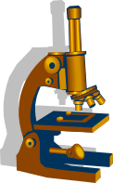 | Our half term topic is Paws, Claws and Whiskers, so we will be learning all about animals. Children will be researching what animals eat and learning the terms carnivore, herbivore and omnivore.  Children will also be learning how to classify animals as mammals, fish, birds, reptiles or amphibians.  We will also be adopting a polar animal. | - Use books, an iPad or laptop to do some research on animals  - Encourage children to make a fact file about their favourite animal  - If possible, visit a pet shop or zoo to look at some animals a little closer
PE   | Children will learn about the different ways we can travel, for example crawling, walking, jumping, hopping and side-stepping. Children will learn about the importance of warming up before exercising and cooling down afterwards. They will learn about the health benefits of exercise. | - Promote the importance of a healthy lifestyle by going on family walks, swimming and cooking healthy foods together.
Art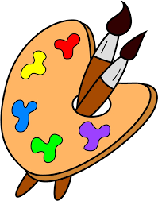 | Children will be learning about Jean Miro and his surrealist style. They will be completing their own pictures and paintings in his style.  Year 1 will be creating their own Artist’s books in the style of Jean Miro’s livre d’artiste. | - Research these artists together  - Practise printing with different objects like sponges, strings or even cut up vegetables and fruit!
Music   | Children will learn about rhythms and how to maintain and alter them. They will use a mixture of tuned and untuned instruments to create different rhythms.  Children will listen to a range of orchestral pieces, including Carnival of the Animals, Flight of the Bumblebee and Dance of the Sugarplum fairy. They will discuss what they can hear and create their own pieces to reflect the composer’s style. | - Use body percussion to create different rhythms together  - Encourage children to listen to a range of different music and talk about what they can hear and whether they like it or not.
ICT   | Children will begin to explore digital texts, using different devices to create their own digital content.  They will also learn about eSafe practice. | - Use apps on iPads or phones where children can create music or pictures  - Encourage children to type on a computer or laptop and see how it is different to writing  - Speak to children about the importance of e safety

