**Wk 1** :

**Literacy:** Jack and the Beanstalk

**Maths:** measures – length and height

**KUW:** planting and growing

**RE:** Gathering/Eucharist

**HWK:** Draw an label what is at the top of the beanstalk.

**Wk 3**

**Literacy**: The Hungry Caterpillar

**Maths**: Finding one more for numbers up to 5

**KUW:** Life cycles – hatching butterflies

**RE:** Baptism

**HWK:** Favourite foods

**Wk 2**

**Literacy:** Jack and the Beanstalk

**Maths** Comparing 2 groups of objects – saying when they have the same number

**KUW:** Shrove Tuesday

**RE**: Ash Wednesday Gathering/Eucharist

**HWK:** Rainbow seeds.



**Wk 8**

**Literacy**: The Easter Story

**Maths:** 3D shape

**KUW:** Celebrations

**RE**: Easter

**Wk 4**

**Literacy**: The Hungry Caterpillar

**Maths:** Finding one less for numbers up to 5

**KUW:** Life cycles

**RE**: Baptism

**HWK:** Life cycle of a butterfly

**Growing**

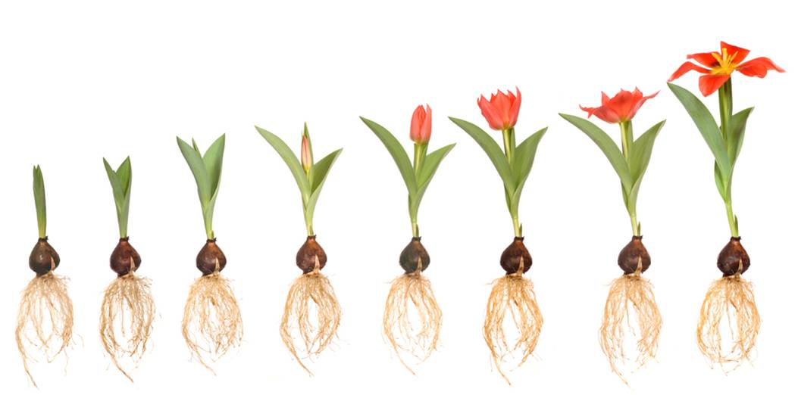

**Wk 6**

**Literacy**: The Enormous Turnip

**Maths:** Matching numeral to quantity to 5

**KUW:** ICT- Spheros

**RE**: Baptism

**HWK:** Can you share something with a friend?

**Wk 7**

**Literacy**: The Easter Story

**Maths**: 2D shape

**KUW:** Celebrations

**RE:**Easter

**HWK:** Easter bonnet

**Wk 5**:

**Literacy:** The Enormous Turnip

**Maths:** Measures – weight and capacity

**KUW:** Mothering Sunday

**RE**: Baptism

**HWK:** pushing and pulling