**Maths**

Number and Statistics

How do we gather and present data?

Year 3

Summer 1

Predators

**Literacy**

**Sheep Pig is our class text this term and we will be covering these aspects of the curriculum:**

**Recounts**

**Fact files**

**News Reports**

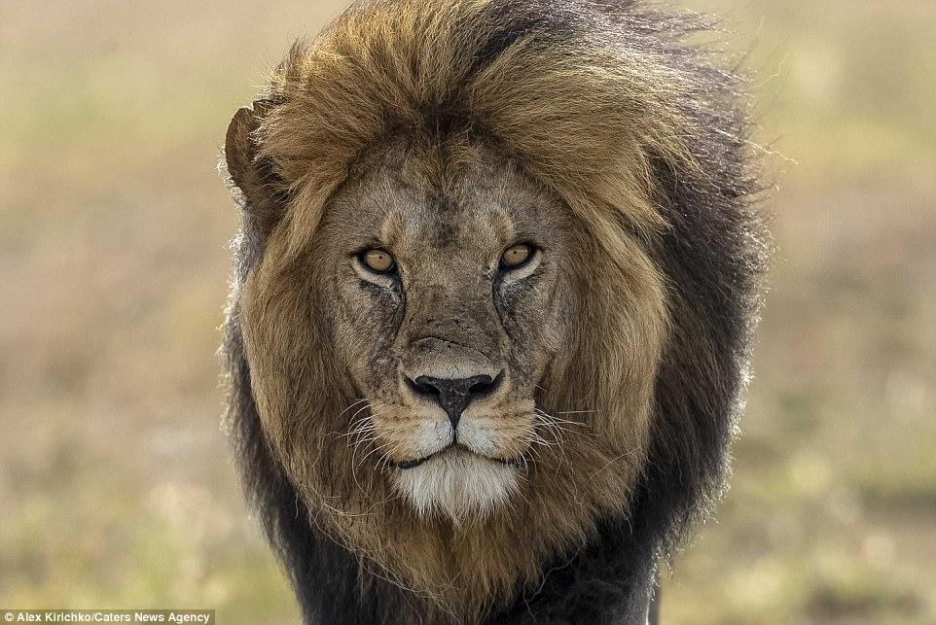

**PE**

**Athletics**

**Our PE days are**

**Tuesday & Thursday**

**RE**

**Local Church**

**Baptism**

**Art/DT**

**Sketching using pencil.**

**The children will look at a range of pencil types and techniques and use them to sketch feathers.**

**Science**

**Forces- We are astronauts!**

**This term we will be exploring different forces.**

**We will learn all about magnets and experiment to find magnetic/non-magnetic materials.**

**ICT**

**Developing**

**Communication**

**Geography**

**Where do different predators come from? Why is their climate important?**