**Maths**

**Number and Revision gaps**

**We will use this opportunity to re-cover any areas that the children found difficult.**

Year 3

Summer 2

Gods and Mortals

**Literacy**

**Our class text this term will be Greek Myths and we will be covering these aspects of the curriculum:**

**Leflets/brochures**

**Myths**

**Reports**

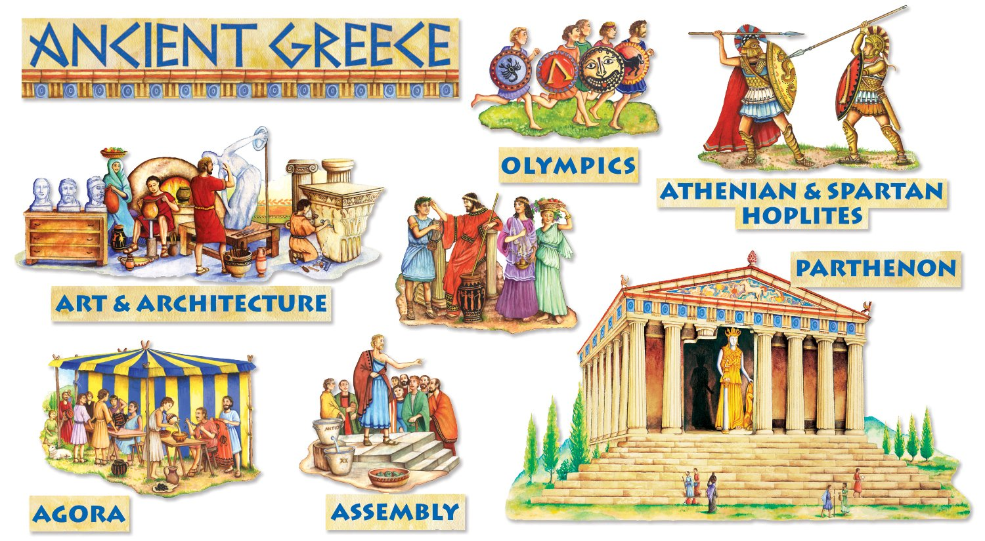

**PE**

**Athletics**

**Our PE days are**

**Tuesday & Thursday**

**RE**

**Local Church**

**Baptism**

**Art/DT**

**In art we will be drawing/ painting-repeated patterns and mosaic patterns**

**Science**

**Opposites attract**

**ICT**

**Developing**

**Communication**

**Geography**

**Maps**

**Ancient and modern day Greece**