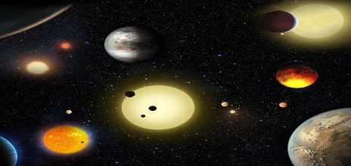

How can you help?

* Research space and the different planets together
* Talk about the similarities and differences between the planets
* Look at the night sky together and talk about what you can see
* Practise counting in 2s to 20, in 5s to 50 and in 10s to 100
* Practise solving subtractions by jumping backwards on a number line
* Practise reading and writing the 100 HFWs that are in your child’s reading record.
* Make rockets using junk modelling.
* Make paper aeroplanes and find the best way to make them fly.
* Read with your child every night. Don’t forget the HFW in their envelope!
* Looking for a day out? Visit Jodrell Bank in Macclesfield to see the Lovell Telescope

**Spring 1: Space**

We will be learning to:

**Mathematics (M)**

* Recognise and sort odd and even numbers
* Recite and use bonds to 10 e.g. 3&7, 6&4
* Add using a number line
* Use ordinal numbers (1st-5th)
* Recognise and describe the properties of 3D shapes
* Recognise coins up to 20p and find out how much I have altogether
* Subtract on a number line
* Count in 2s, 5s and 10s

**Communication and language (C&L)**

* Compose our own questions using: who, what, why, when, where
* Answer questions and ask questions about space
* Retell a story
* Orally compose own story using props

**Personal, social and emotional development (PSED)**

* Feel confident and proud of ourselves and others
* Say things that we are good at
* Try to solve conflicts ourselves before coming to an adult for help
* Speak to others about what we have learnt about space



**Understanding the World (KUW)**

* Identify materials and talk about their properties
* Talk about and investigate how craters are made on the moon

Reminders:

* Please check bags for letters and homework.
* Homework will be sent home on a Friday. Please send it back by Wednesday morning.
* PE is on a Tuesday afternoon.
* Please add photographs and comments onto your child’s learning journey
* When you drop off your child please feel free to speak to your child’s teacher about all the fantastic work they have been doing at home. You might even want to bring it in to show the class.
* Please bring in any empty boxes/containers etc. for children to use in our creative area.
* Don’t forget to bring in your reading book every day and put it in either the red or green box.

**Expressive Art and Design (EAD)**

* Sing space songs
* Make pictures in the style of Peter Thorpe
* Find ways to make our creations even better
* Make up our own stories to build-up our own role-play
* Recreate Peter Thorpe’s space art

**Literacy (L)**

* Retell stories and begin to write them
* Make up our own stories using different sentence starters e.g. Once upon a time, One day, Suddenly, Next
* Use adjectives
* Use capital letters and full stops when writing multiple sentences

**Physical Development (PD)**

* Form all letters correctly
* Begin to form capital letters
* Control letter size and write on the line
* Do our own buttons
* Prepare for sports day