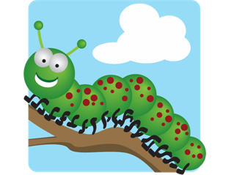

**Summer 1/2: Minibeasts**

How can you help?

* Talk about different minibeasts you see.
* Talk about similarities and differences between minibeasts.
* Make your own minibeast hotel.
* Go to the library and look at books about different minibeasts.
* Practise letter formation with your child. Make sure they are starting at the top.
* Practise counting from 1-100 and back from 20-0.
* Practise reading and writing the 100 HFW that are in your child’s reading record.
* Play free educational games online (google ictgames and topmarks)
* Practise using scissors at home.
* Look on Pinterest for fine motor activities. These will help your child to hold and control their pencil e.g. using playdough, using tweezers
* Read with your child every night. Don’t forget the HFW in their envelope!

We will be learning to:

**Communication and language (C&L)**

* Use words such as “first”, “next” and “then”, when retelling an event
* Answer and ask questions about minibeasts
* Use past, present and future tenses correctly
* Listen attentively in a range of situations

**Personal, social and emotional development (PSED)**

* Speak to others about what we have learnt about minibeasts
* Try new activities and say why we do/ don’t like them
* Listen to each other and take note of each other’s ideas

**Mathematics (M)**

* Subtract 2 numbers and write number sentences
* Solve word problems
* Solve problems that involved doubling, halving and sharing
* Recognise money and make different amounts
* Count and recognise numbers to 100
* Count in 5s and 10s

Reminders:

* Please check bags for letters and homework.
* Homework will be sent home on a Friday. Please send it back by Wednesday.
* When you drop off your child please feel free to speak to your child’s teacher about all the fantastic work they have been doing at home. You might even want to bring it in to show the class.
* Please bring in any empty boxes/containers etc. for children to use in our creative area.
* Don’t forget to bring in your reading book every day and put it in either the red or green box.

**Expressive Art and Design (EAD)**

* Sing minibeast songs
* Use scissors, glue and cellotape correctly
* Move in time to the music

**Literacy (L)**

* Read and write non-fiction texts
* Write multiple sentences
* Use capital letters and full stops
* Leave finger spaces between words
* Read and write the 100 high frequency words (HFW)

**Physical Development (PD)**

* Show good control
* Control letter size
* Form our letters correctly by always starting at the top
* Say why exercise and a healthy diet are important



**Understanding the World (KUW)**

* Identify different minibeasts
* Talk about different environments
* Talk about the similarities and differences between minibeasts