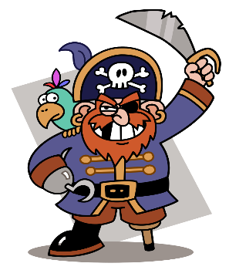

How can you help?

* Research famous pirates together e.g. Anne Bonney, Captain Blackbeard
* Make maps together.
* Talk about different places the pirates visited and how they lived.
* Practise counting from 1-100 and back from 20-0.
* Practise 1 more and 1 less than up to 20
* Look for different 3D shapes and talk about what they look like.
* Practise reading and writing the 100 HFW that are in your child’s reading record.
* Play free educational games online (google phonicsplay and topmarks)
* Practise using scissors at home.
* Look on Pinterest for fine motor activities. These will help your child to hold and control their pencil e.g. using playdough, using tweezers
* Read with your child every night. Don’t forget the HFW in their envelope!

**Spring 1: Walk the Plank**

We will be learning to:

**Mathematics (M)**

* Recognise coins and make different amounts
* Order items in terms of weight and capacity
* Recognise and talk about properties of 3D shapes (sphere, cube, cuboid, cone, pyramid)
* Say the number that is 1 more and 1 less than
* Count beyond 20
* Write number sentences

**Communication and language (C&L)**

* Use words such as “first”, “next” and “then”, when retelling an event
* Compose our own questions using: who, what, why, when, where
* Answer questions and ask questions about pirates
* Retell a story

**Personal, social and emotional development (PSED)**

* Feel confident and proud of ourselves and others
* Say things that we are good at
* Try to solve conflicts ourselves before coming to an adult for help
* Speak to others about what we have learnt about pirates



**Expressive Art and Design (EAD)**

* Make boats that float
* Sing pirate songs
* Mix colours
* Find ways to make our creations even better
* Use stories/ information that we have learnt, to build up a role play

**Understanding the World (KUW)**

* Make our own maps
* Talk about floating and sinking
* Talk about who pirates were and what they did

Reminders:

* Please check bags for letters and homework.
* Homework will be sent home on a Friday. Please send it back by Wednesday.
* When you drop off your child please feel free to speak to your child’s teacher about all the fantastic work they have been doing at home. You might even want to bring it in to show the class.
* Please bring in any empty boxes/containers etc. for children to use in our creative area.
* Don’t forget to bring in your reading book every day and put it in either the red or green box.

**Literacy (L)**

* Retell stories
* Begin to write short sentences
* Use adjectives
* Use capital letters and full stops
* Leave finger spaces between words
* Read and write the 100 high frequency words (HFW)

**Physical Development (PD)**

* Hold our pencil using a tripod grip
* Get dressed by ourselves
* Form our letters correctly by always starting at the top